Worship Packet for July 19, 2020

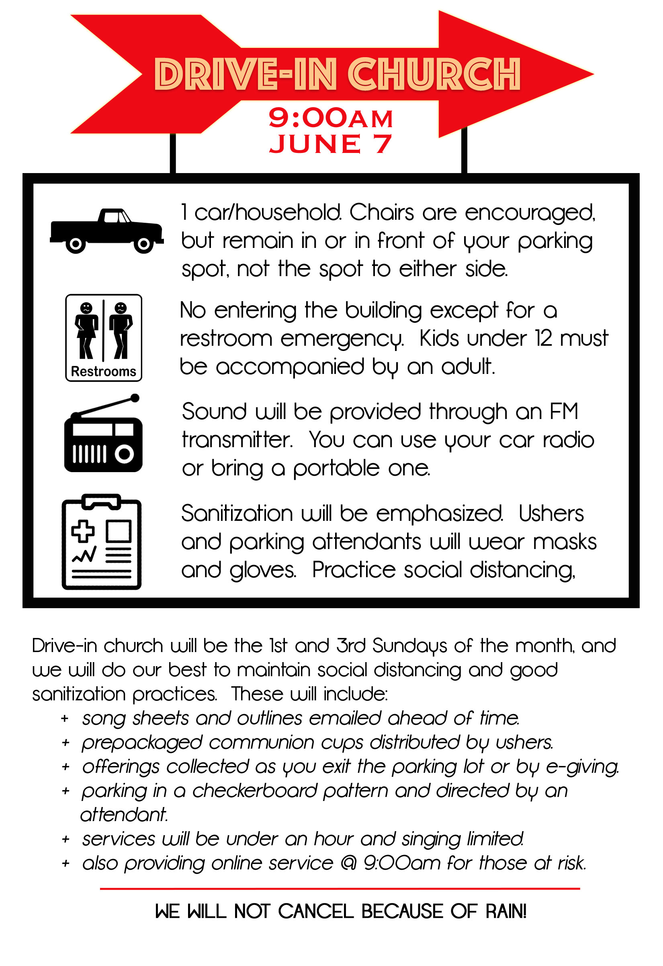

Goodness Of God

Verse 1
I love You Lord
Oh Your mercy never fails me
All my days
I've been held in Your hands
From the moment that I wake up
Until I lay my head
I will sing of the goodness of God

Chorus
All my life You have been faithful
All my life You have been so so good
With every breath that I am able
I will sing of the goodness of God

Verse 2
I love Your voice
You have led me through the fire
In darkest night
You are close like no other
I've known You as a father
I've known You as a friend
I have lived in the goodness of God

Bridge
Your goodness is running after
It’s running after me
Your goodness is running after
It’s running after me
With my life laid down
I’m surrendered now
I give You everything
Your goodness is running after
It's running after me
CCLI Song # 7117726

Indescribable

Verse 1
From the highest of heights to the depths of the sea
Creation's revealing Your majesty
From the colors of Fall to the fragrance of Spring
Ev'ry creature unique in the song that it sings
All exclaiming

Chorus 1
Indescribable uncontainable
You placed the stars in the sky
And You know them by name
You are amazing God
All powerful untamable
Awestruck we fall to our knees
As we humbly proclaim
You are amazing God

Verse 2
Who has told ev'ry lightning bolt where it should go
Or seen heavenly storehouses laden with snow
Who imagined the sun and gives source to its light
Yet conceals it to bring us the coolness of night
None can fathom

Interlude
You are amazing God

Chorus 2
Indescribable uncontainable
You placed the stars in the sky
And You know them by name
You are amazing God
Incomparable unchangeable
You see the depths of my heart
And You love me the same
You are amazing God

Ending
You see the depths of my heart
And You love me the same
You are amazing God
(REPEAT)
You see the depths of our hearts
And You love us the same
You are amazing God
CCLI Song # 4403076

WHY LET THE WEEDS GROW?
July 19, 2020
Matthew 13:24-30, 36-41

- What is a weed? - A plant that’s not ____________________, that we didn’t _______________, that grows where we don’t ______________ it to grow.

- When Jesus told this parable, he was talking about ___________________________ weeds.

- When it comes to spiritual weeds, there are no _________________.

- Why does God allow evil to exist? Because when you are pulling the weeds, you may uproot the __________________ with them.

- God has designed the perfect weed-killing ___________________.

- As much as God hates weeds, He’s not in a big hurry to __________ them.

- Over and above any happiness or sadness we feel, there should be a great sense of
__________________________.

benefits formula kill plant spiritual

urgency want wanted wheat

Communion
The Lord’s Prayer:
Our Father which art in heaven, hallowed be Thy name. Thy kingdom come, Thy will be done, on earth as it is in heaven.

Give us this day, our daily bread, and forgive us our debts as we forgive our debtors. And lead us not into temptation but deliver us from evil. For Thine is the kingdom, and the power, and the glory forever. Amen

The Collect:
Almighty God, unto whom all hearts are opened, all desires known, and from whom no secrets are hid:

Cleanse the thoughts of our hearts, by the inspiration of the Holy Spirit, that we may perfectly love You and worthily magnify Your holy name, through Christ Our Lord. Amen.

